**Leader Overview**

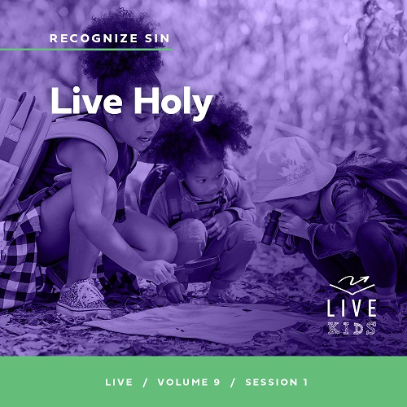

**Volume Overview**

**Recognize Sin**

*The Bible has a lot to say about sin and forgiveness. It acknowledges the deep brokenness of this world and our individual life. It is only by understanding the depth of human sin that we can understand the remarkable work of God’s forgiveness. Because of His forgiveness, we escape the eternal consequence of our sin and can rightly respond to the call to live a holy life. We learn to receive forgiveness, put off sin, and show forgiveness to those who have sinned against us. We learn to pursue holiness in the midst of the world’s brokenness.*

**Session Overview**

**Live Holy**

*In this* **Live** *session, kids will discover that God wants us to live a holy life. To do this, we must be willing to let go of the sin and behavior that holds us back. When we do this, we not only honor God but also can experience a life closer to the way God intended.*

**Bible Lesson**

Jesus Clears the Temple

[Mark 11:15–19](https://ref.ly/logosref/Bible.Mk11.15-19)

**Faith Fact**

I will leave my sin behind.

**Faith Verse**

[2 Corinthians 5:17](https://ref.ly/logosref/Bible.2Co5.17)(NLT)

Anyone who belongs to Christ has become a new person. The old life is gone; a new life has begun!

**Preparing for the Session**

**Leader Preparation Time: 20–25 Minutes**

|  |
| --- |
| ***You Will Need***  ***Large Group***   * *Bible* * *Worship songs (Song suggestions: “Free Indeed” Lyric Video by Planetshakers; “I Thank God” Lyric Video by Maverick City; “Trust” Lyric Video by Hillsong Young and Free; “Reckless Love” Lyric by Cory Asbury)* * *For groups not using a phone or tablet only, add:*   *• Projector or TV*  *• Laptop*  *•* ***Faith Fact Slide***  *•* ***Faith Verse Video*** *or* ***Slide***  *•* ***Bible Lesson Video***  *•* ***Teaching Point Slides 1–3***   * *Bucket or box for a goal* * *Soft balls or paper wads* * *Smartphone or timer* * *Lunchbox with healthy snacks* * *Lunchbox with junk food* * *Package of cookies* * *Paper, one sheet per kid* * *Pencils, one per kid* * *Basket*   ***Small Group***   * + *Backpack*   + *Heavy items for kids to carry in the backpack*   + *Bibles for kids in the group to share*   + *Whiteboard*   + *Dry erase markers*   + *Whiteboard eraser*   + ***Small Group Activity Page****, one per kid*   + *Pencils or pens, one per kid*   *To access session content and videos from a computer, visit:* [*BibleEngagementProject.com/downloads*](https://bibleengagementproject.com/downloads) |
| ***Getting Ready***  ***Large Group***   * *Download videos and slides if needed.* * *Select worship song(s) and have them ready to play.* * *Read the Bible Lesson Scripture to prepare for Teaching Time.*   ***Small Group***   * *Fill the backpack with the heavy items. Make the weight appropriate for the size of the kids in your group.* * *Write the Faith Verse on the whiteboard.* * *Print copies of the* ***Small Group Activity Page****, one per kid.*   *First time leading* Live *for Kids? Check out the* [*Facilitator Guide*](https://0b769b0ed3569ef9d18b-f88d8272f61086866d50d048b43ef630.ssl.cf2.rackcdn.com/sites/biblengagementproject/Listen_Facilitator_Guide.pdf)*.* |

**Large Group**

**30 Minutes**

*See what’s needed at the beginning of the session.*

**Introduction**

What’s up, everybody? I’m thrilled to be here with you! Today, we’ll talk about leaving things behind. Raise your hand if you’ve ever forgotten something at home that you were supposed to bring to school. *(Group response.)* Looks like that’s happened to a lot of us! There are so many things you need to remember. Backpacks, homework, permission slips, sometimes a jacket or sweater, and lunch. Ugh! Forgetting your lunch or your lunch money is one of the worst feelings ever!

Today, we’ll talk about leaving something behind on purpose. Can anyone guess what it is? *(Allow responses.)* Sin! We’ll discover how sin in our life can hold us back from all the amazing things God wants for us. Raise your hand if you want to make sure there is nothing in the way of you living God’s best life for you. *(Group response.)* Me too!

**Faith Fact**

Talking about leaving things behind reminds me of our Faith Fact for today. **I will leave my sin behind.** In our Bible story today *(hold up the Bible)*, we’ll see how Jesus wanted the people in the temple to leave behind sin because it was distracting them from worshipping God.

• *Show the* ***Faith Fact Slide.***

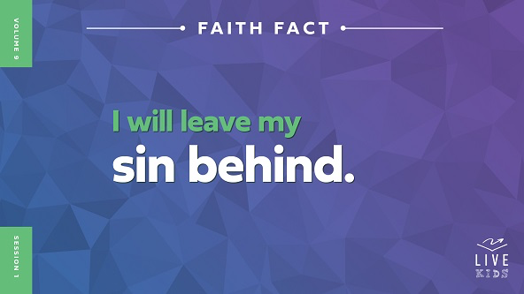

Sometimes it can be hard to know how we can leave sin behind. Thankfully, God helps us move forward past our mistakes so that we can leave sin behind. As we say our Faith Fact, point at yourself and then behind your back *(demonstrate)*. **I will leave my sin behind.** One more time. **I will leave my sin behind.** Well done!

**Game**

**Throw It Behind**

Let’s practice leaving things behind with a game called Throw It Behind. We aren’t just leaving things behind in this game. We’ll throw them. Here’s how the game works. We’ll form two teams to play. Each team will have one person come up at a time to try and score a point. When it’s your turn, you’ll face away from the goal. Then, you’ll throw the ball over your head without looking back and try to hit the goal. If you make it, your team will get a point. After each person throws, they’ll go to the back of the line. Whichever team has more goals after a minute wins.

• *Form the teams and choose the ball retrievers.*

• *Start the timer for one minute.*

• *Have the group keep score for each team competing.*

Great job, everyone! Thanks for showing us how to get things behind you. Hopefully, after our Bible story today, you’ll see how God wants you to throw something more important behind you—sin. Let’s say the Faith Fact together as a reminder. **I will leave my sin behind.**

**Worship**

One way we can start to leave our sin behind is to focus on God. When we worship God, we remember how great He is, which helps us want to honor Him more. Who’s ready to worship God? *(Group response)* Let’s worship Him by singing together.

• *Lead the kids in singing one or two praise songs. See suggestions at the beginning of the session.*

**Bible Lesson**

Thanks for worshipping with me, everyone! When we worship God, He can help us recognize anything in our heart, mind, or behavior that is holding us back. Remember our Faith Fact? **I will leave my sin behind*.*** We’ll see what the Bible says about this. Let’s pray and then get started with the Bible story.

**Prayer**

|  |
| --- |
| *Dear God, thank You for wanting the best for us. Help us to know today how we can choose to honor You no matter what sin You want us to leave behind. Our hearts are open to whatever You need to say to us. In Jesus’ name. Amen.* |

**Video Intro**

Just before we look at the Bible story, let’s watch this video.

• *Play* ***Bible Lesson Video****.*

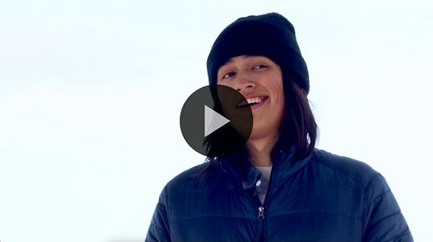

**Bible Story**

**Jesus Clears the Temple**

Have you ever been in a situation like Dash before? *(Group response)* Thankfully, God’s Word was able to help Dash recognize how easily sin could creep into his life. Let’s look at that Bible story about Jesus to learn more about leaving sin behind.

**Teaching Time**

|  |
| --- |
| ***You Will Need***   * *Lunchbox with healthy snacks* * *Lunchbox with junk food* * *Package of cookies*   *No prep needed for this activity.* |

Jesus was with His disciples, and they were traveling around together. He had been teaching people the good news about God’s love for them, seeing miracles happen, and watching people’s lives be forever changed. They went to Jerusalem, which was a big city and crowded with people.

They headed to the temple, which was kind of like our church. The priests were in charge of caring for the temple and leading the people in their worship of God. What’s crazy is that at the temple the priests were actually allowing some things that made Jesus pretty upset. Jesus knew He needed to fix it.

Jesus cares a lot about the Church, and He wants everyone, including us, to honor all of God’s ways. Let’s find out more about what happened. Grab your Bible or pull up a Bible app on your device. Turn to [Mark 11:15–19](https://ref.ly/logosref/Bible.Mk11.15-19).

• *In order to keep Large Group time moving along, we recommend that the leader reads the Scripture portions aloud.*

• *Optional: Remind the kids to mark this place with their Bible bookmark so they can read it on their own at home.*

**1. Jesus cleared the temple of bad things.**

• *Show the* ***Teaching Point 1 Slide.***

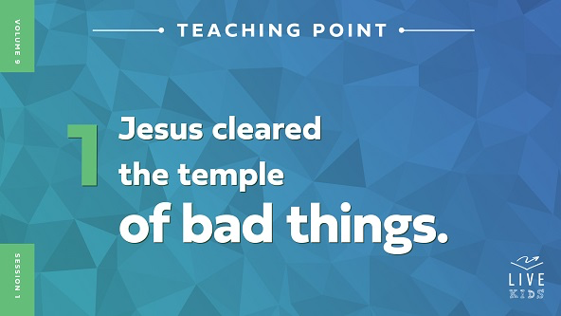

• *Read* [*Mark 11:15–16*](https://ref.ly/logosref/Bible.Mk11.15-16)*.*

Wait a second! Did you hear that? Jesus did what? Jesus flipped people’s tables over and made them leave the temple. Does this sound like something we would normally think that Jesus would do? *(Group response)* There had to be a good reason for it, right? *(Group response)*

There was. The reason Jesus was upset was that the temple was being used as a place to get extra money from the people who were there to worship God. What do you think the money changers and the animal sellers thought of Jesus turning their tables over and kicking them out? Show me how you think their faces may have looked. *(Group response)*

• *Grab the lunchboxes and show each one as you talk about it.*

Let’s think about this another way. What kinds of things do you like to have for lunch at school? *(Allow responses.)* Those are some tasty foods! How many of you would rather have a lunch full of candy and junk food instead of one full of healthy foods like vegetables? *(Group response)* I think most of us would want the candy and snacks. But, just because a food is tasty doesn’t mean we should always eat it, right? *(Group response)*

How many of you know that if you want to be healthy and strong, you need to have a balanced diet of many different types of foods, including vegetables and fruit? *(Group response)* It can be tempting to forget all the healthy food and eat only what we like instead.

That’s like what the people selling stuff in the temple were doing. They had left behind the good things they needed to do to follow God, and they were trading it for unhealthy things. They knew the temple was a place to worship not a marketplace. Jesus wanted to keep that special place healthy so people could worship God there like He intended. That’s why Jesus got so upset. Let’s see how the leaders of the temple responded after Jesus flipped those tables.

**2. Jesus cared a lot about the temple.**

• *Show the* ***Teaching Point 2 Slide.***

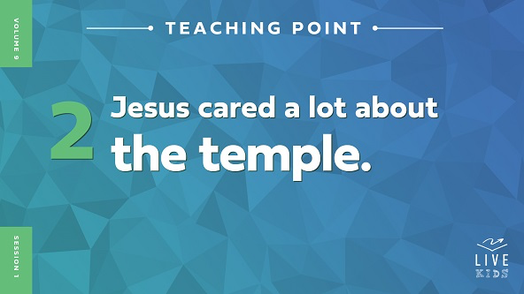

• *Read* [*Mark 11:17–19*](https://ref.ly/logosref/Bible.Mk11.17-19)*.*

Jesus didn’t just get upset and throw around stuff at the temple. He was careful to explain to the people why He was upset and what they should have been doing instead. People were using a special place for worshipping God as a place to make extra money for themselves. Jesus said that the temple should be a place where people gathered to pray, not to shop. Do you think the religious leaders at the temple were okay with Jesus saying that? *(Group response)*

The people in charge of the temple didn’t like what Jesus was doing at all! The other people in the temple were probably amazed at what Jesus said. It’s kind of like this.

• *Invite a volunteer to come up and eat some cookies while you share the next part. Hand the package of cookies to the volunteer.*

Imagine that your friend came to you while you were eating a whole bunch of cookies during lunch and said, “Hey, you shouldn’t be eating that much sugar. It’s not healthy for you.” How do you think you might feel? Shout it out. *(Group response)*

It would be easy to feel mad, hurt, or embarrassed about eating all the cookies. I’m pretty sure that none of you would think eating a whole package of cookies at one time is healthy or a good idea. I think our volunteer can stop now.

• *Pause while the volunteer is seated.*

The same is true about sin. We know better, but sometimes we make bad decisions. We choose to ignore what we know is right and choose something that we want in the moment instead. It’s like when we trade our healthy lunch for the junk food.

Jesus was telling the people that they had traded what they knew was right for junk that wasn’t helping anyone or honoring God. Because Jesus cared about the temple being a place of worship, He wasn’t afraid to speak up about it. Let’s check out another place in God’s Word that shows us what God thinks about this.

**3. God wants us to leave behind our old life.**

• *Show the* ***Teaching Point 3 Slide.***

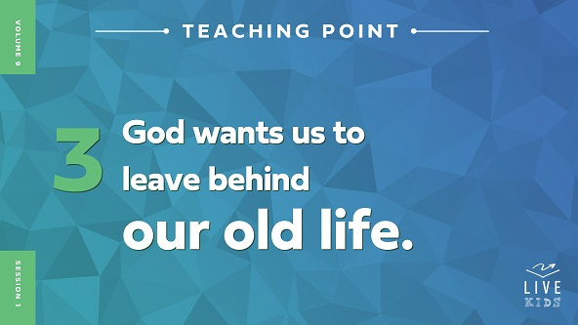

• *Read* [*Ephesians 4:22–23*](https://ref.ly/logosref/Bible.Eph4.22-23)*.*

These verses tell us to not listen to our desires because what we want can trick us into thinking that what’s wrong is right. We need to leave those things behind us and choose to follow what God tells us to do. Our old way of life is doing what we want, including choosing to sin. Our new way of life is choosing to do what God wants.

How many of you think it’s hard to always choose what God wants instead of what you want? *(Group response)* It can be really hard! How many of you know that it’s always worth it to follow God? *(Group response)* He wants us to choose His ways and to leave behind our sinful ways.

We aren’t putting them down for a little while to pick them back up later. God wants us to leave sin behind and never go back to it. Then, we can see how much better life is when we trust Him and follow His instructions. Our Faith Fact today is a great reminder. Let’s say it together. **I will leave my sin behind**.

**Prayer and Response**

*Consider playing a worship song softly in the background while kids pray.*

|  |
| --- |
| ***You Will Need***   * *Paper, one sheet per kid* * *Pencils, one per kid* * *Basket*   *No prep needed for this activity.* |

God wants to help us recognize sin in our life so that we know what to leave behind. God wants our life to honor Him. He doesn’t want us to do what He says because He says so but because He wants us to have the best life possible. That’s what happens when we listen to God.

Today, we’ll ask God what He wants each of us to leave behind. This could be a sin that He wants us to stop doing like lying or being unkind to someone. Maybe God wants you to leave behind being jealous because it keeps you from being right with Him.

• *Give each kid a piece of paper and a pencil.*

As we pray, let’s listen for what God wants to say. When you know what God wants you to let go of, write it on your piece of paper. Then, leave it in the basket. As you do this, imagine that you are letting it go and leaving it behind you so that you won’t pick it up and do it anymore.

• *Give kids some time to pray and respond. Then close in prayer.*

**Prayer**

*Optional: Have the kids repeat phrases of the prayer after you.*

|  |
| --- |
| *Dear God, thank You for helping me leave my sin behind. Help me to not trade a healthy relationship with You for any junk in my life. I want to recognize anything that gets in the way of me knowing who You are. In Jesus’ name. Amen.* |

**Faith Verse**

Today’s Faith Verse reminds us that when we follow Jesus, we are a totally new persons! That’s what happens when we leave our sin behind. Nothing from our old ways can keep us away from Him. Let’s learn it together.

• *Play* ***Faith Verse Video****.*

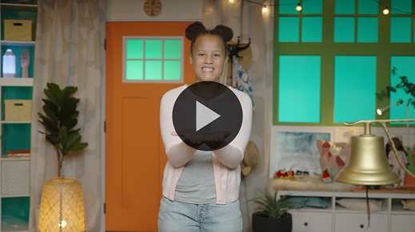

[2 Corinthians 5:17](https://ref.ly/logosref/Bible.2Co5.17) (NLT)

Anyone who belongs to Christ has become a new person. The old life is gone; a new life has begun!

Let’s say that verse together all at once. *(Group response)* Great work! Let’s say that verse one more time as slowly as we can. *(Group response)*

**Faith Fact**

Before we go to our small groups, let’s review our Faith Fact again. **I will leave my sin behind.**

• *Show the* ***Faith Fact Slide****.*



Let’s say that Faith Fact together. **I will leave my sin behind.** Point at yourself and then behind you as we say it again. **I will leave my sin behind.**

• *Dismiss kids to Small Group time or to go home if your group time ends here.*

**Small Group**

**30 Minutes**

*This section can be done in conjunction with the large group or on its own if you do small groups with your kids. During Small Group time, the goal is to connect the kids with the Word of God and to each other. All activities are led by the small group leader.*

**Group Connection**

**Leave the Burdens Behind**

|  |
| --- |
| ***You Will Need***   * *Backpack* * *Heavy items for kids to carry in the backpack*   ***Getting Ready***   * *Fill the backpack with the heavy items. Make the weight appropriate for the size of the kids in your group.* |

In our Bible story, we heard how Jesus wanted the people at the temple to do what was right and to worship God. When we let go of our sins, it’s like a burden is lifted off us.

• *Hold up the backpack.*

To symbolize what it’s like to carry sin, we’ll take turns putting on this heavy backpack and walking around our group. Once you get back to your seat, share with the group an example of a sin someone might need to leave behind as they do their best to follow Jesus. Then, give the backpack to the next person.

• *Help kids as needed to think about responses.*

• *Allow each kid to take a turn carrying the backpack.*

**Bible Lesson Recap**

• *If small group activities are not immediately following large group time, you may want to read the Bible story passage before the discussion.*

|  |
| --- |
| ***You Will Need***   * *Bibles for kids in the group to share*   *No prep needed for this activity.* |

**Bible Story Review: Jesus Clears the Temple** [**Mark 11:15–19**](https://ref.ly/logosref/Bible.Mk11.15-19)

What was the most interesting thing about the Bible story we heard today? *(Allow responses.)* Those are great answers! To review, Jesus came to the temple and got really upset at what was happening there. He flipped over the money tables and taught the people not to use God’s temple for something it wasn’t supposed to be used for. Instead, the temple should be a place where they worshipped God.

Why should we try our best to leave our sin behind us? *(Allow responses.)* We were never supposed to have sin in our life, but sadly we do. As we honor God, listen to His Word, and obey Him, we get a chance to see how amazing God is and to discover the joy of living a life that honors God.

• *Give each kid a Bible and read the Bible story together.*

**Group Discussion**

*Feel free to use all or just a few questions as a jumping-off place for good discussion. Questions marked with * are designed for more conversation. Adjust the questions based on the age or maturity of your group. Typically, older kids will be able to dive a little deeper than younger ones.*

**Questions**

Who was with Jesus when He went to the temple?

* What did Jesus do when He got to the temple? Why?

* How do you think people reacted to Jesus flipping over the tables at the temple?

Do you think they were surprised that Jesus was so upset? Why or why not?

Do you think the people selling animals in the temple knew that what they were doing was sin? Why or why not?

* Have you ever needed to leave sin behind because you were doing something you shouldn’t?

* Why is it important to obey God instead of just doing what we want to do?

* How can you leave sin behind this week?

**Live It**

**Faith Fact**

Our Faith Fact is **I will leave my sin behind.** Jesus showed that it’s important to leave sin behind and choose to honor God. Earlier, we wrote down something we needed to leave behind in our life.

**Challenge**

The challenge for this week is to share what you wrote with someone important in your life, such as your parent or a leader here, so that they can encourage you. Choose someone who will pray for you as you do your best to leave behind any sin that Jesus doesn’t want in your life. This might be something that makes you nervous, but it can help a lot to ask for help.

**Prayer**

*Finish group discussion by sharing prayer requests and praise reports. Keep track of your small group’s prayer requests and review them each time you meet.*

• *Have kids share and pray for each other’s prayer requests.*

|  |
| --- |
| *Dear God, thank You for hearing us when we pray. Please help us to honor You. We don’t want to sin, but we know that we aren’t perfect. Help us to leave sin behind even when it’s not easy to do. In Jesus’ name. Amen.* |

**Faith Verse Review**

|  |
| --- |
| ***You Will Need***   * *Whiteboard* * *Dry erase markers* * *Whiteboard eraser*   ***Getting Ready***   * *Write the Faith Verse on the whiteboard.* |

Our Faith Verse is [2 Corinthians 5:17](https://ref.ly/logosref/Bible.2Co5.17). It tells how Jesus makes our life brand-new when we leave sin behind. Let’s go over it together!

• *Show* ***Faith Verse Video****.*



[2 Corinthians 5:17](https://ref.ly/logosref/Bible.2Co5.17) (NLT)

Anyone who belongs to Christ has become a new person. The old life is gone; a new life has begun!

Following Jesus means that we get a fresh start in our life! We aren’t the same person on the inside that we were before giving our life to Jesus. God makes us new! Let’s review our Faith Verse as a group a couple of more times. Try to memorize it because we’ll need to know it for the Faith Verse game.

• *Say the verse as a group a couple of times.*

**Faith Verse Fun**

**Word Wipeout**

We’ve talked about wiping sin out of our life. When we do that, we get rid of our old life just like this verse says. I’ve written the verse on the board, so let’s read it together one time to keep it fresh in our mind. Pay attention because we’re ready to challenge our memory.

• *Read the verse together.*

Now, we’ll take turns wiping away the words one at a time and replacing them with lines. Then, we’ll say the verse again. Let’s see if we can keep saying it as the words disappear.

• *Have the group say the verse. Then, have a volunteer come up and erase one word and replace it with a line. Repeat until the whole verse is gone.*

• *If you’re short on time, consider erasing multiple words at a time.*

Great job, everyone! Memorizing this Faith Verse will remind us why leaving our sins behind is so important!

**Activity Page**

**Hidden Pictures**

|  |
| --- |
| ***You Will Need***   * ***Small Group Activity Page****, one per kid* * *Pencils or pens, one per kid*   ***Getting Ready***   * *Print copies of the* ***Small Group Activity Page****, one per kid.* |

When Jesus arrived at the temple, He didn’t let the crowd of people keep Him from removing things that displeased God. We need to let Jesus do the same thing in our life. He will help us know if we have any hidden sins we need to leave behind. No sin is hidden from Him.

• *Hand out a copy of the* ***Small Group Activity Page*** *and a pencil to each kid.*

Let’s see how good you are at finding hidden things. Circle all the things that you find hidden in the picture on your Activity Page. Some are a different color than the example. And some are partly hidden.

• *Give kids time to complete the page.*

**Dismissal**

Hey, friends! I enjoyed learning from God’s Word with you today! Remember that God wants us to honor Him and leave behind our sins. It’s not just so we follow His rules or do what He says. God knows that our life is the best when we obey Him. Let’s pray together.

**Prayer**

|  |
| --- |
| *Dear God, please help us to honor You. We know that Your ways are best even if we forget that at times. Help us to leave behind any sins that would keep us from following You with our whole heart. In Jesus’ name. Amen.* |

**Faith Fact Recap**

• *Show the* ***Faith Fact Slide****.*



Remember that God wants us to leave behind anything in our life that would get in the way of us connecting with Him. He wants to be close to us. Let’s say our Faith Fact together as a reminder. **I will leave my sin behind.** I’m so glad you came today. I can’t wait to see you next time**.**

• *Send home the* ***Small Group Activity Page.***

• *Remind parents that there are* ***Family Devotions*** *available on the app to do with their kid.*

• *Tell everyone the date and time for the next session.*